Connecting to WAWA network using Remote VPN on HCL Laptop

After getting HCL laptop, to connect to WAWA network using Remote VPN on HCL laptop, please follow below steps –

**Step 1** :- Raise SSD in “Admin Asset Issuance - Application Issues” category under “IT Operation” group for getting laptop’s BitLocker password (valid only for users who get new laptop). Existing users will already have their laptop’s BitLocker password.

**Step 2** :- After getting BitLocker password, refer to “How to Set up your HCL Laptop” document setting up the password. In case of any issues:

**For Noida users**:

* Rahul Ranjan (51792647) – 1st Point of Contact
* Bimlesh Kumar Jha (40103194) – 2nd Point of Contact

**For Bangalore/Hyderabad/Chennai users**:

* Yogesh C (51864818) - 1st Point of Contact
* Maltesh Gouda (51613436) - 2nd Point of Contact
* Santhosh Shetty (40194411) – 3rd Point of Contact

**Step 3 :** - Raise a **Remote Access VPN** request under Service Xchange in *“Remote Access VPN in Access Request Services”* category*.* Service Xchange is available in MyHcl. The request will cover Remote VPN as well as RSA token to be installed on your HCL laptop and mobile phone respectively.

(Sahadevan Kuppadakath (51461617) – Provide the sample user details in case it is asked.

**Step 4 :-** Send an email to [ASD_Support@hcl.com](mailto:ASD_Support@hcl.com) team and mention your request number (from Step 3). Keep RM and [sharad-v@hcl.com](mailto:sharad-v@hcl.com) in Cc while sending the mail.

**Step 5:** -

Follow the steps mentioned by ASD_Support team to install and get RCA token on your **android phone**. (Remember this token is only for android phone if you have iPhone – please check with ASD_Support team).

Below is a sample email received from ASD_Support team for RCA token instruction.

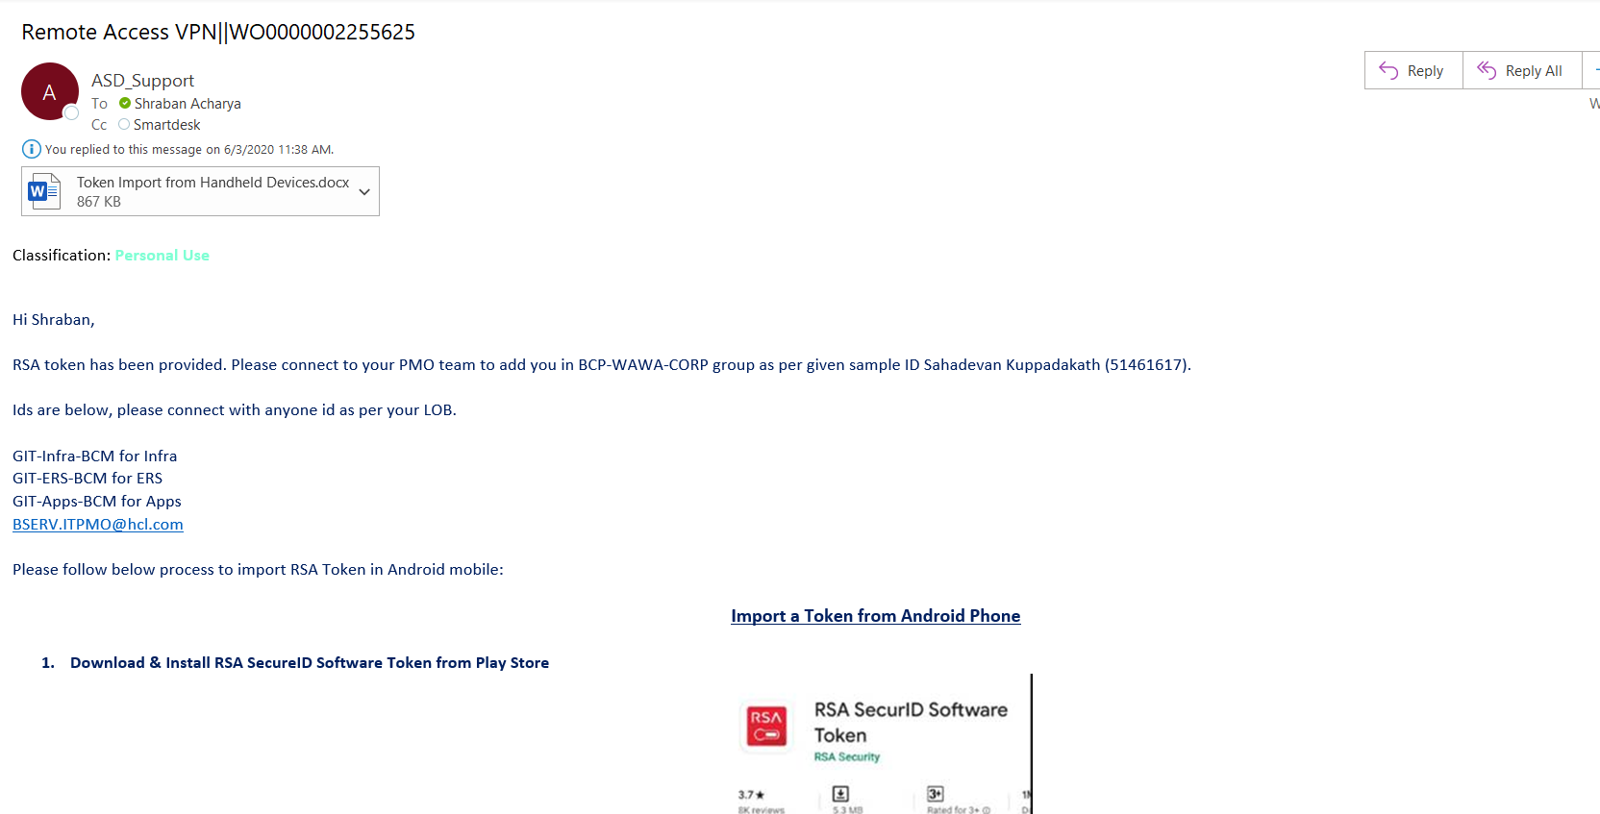

**Step 6: -** Once you have RSA token, try connecting to VPN with URL - myvpn-in2.hcl.com

Username – HCL username & password is – passcode generated by RSA token.

Below is a sample screen shot for my VPN -

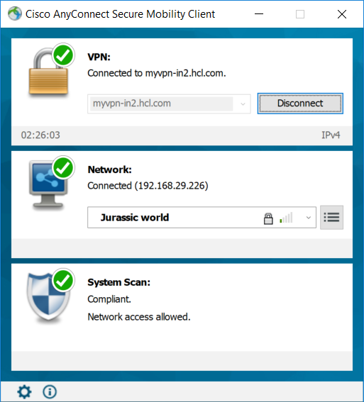

**Step 7**: - Only for DATA track users:

**For Host entry request** – Raise a serviceXchange request (under break fix) & mention – “Host File Entry to be done for Workspace.wawa.com 172.29.10.1”

Once the IT support team is reaching you ask for below 2 entries in your host file.

127.0.0.1 view-localhost # view localhost server

172.29.10.1 Workspace.wawa.com

Below is a sample host file view from my local machine for reference -

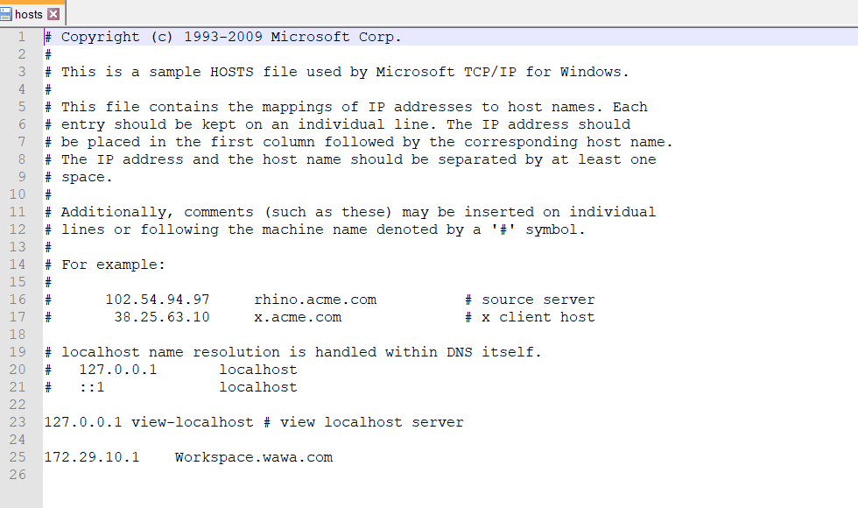

**Step 8**:

Restart your laptop and try to access <https://workspace.wawa.com/logon/LogonPoint/tmindex.html>

If you can see below page, then you have successfully completed established the WAWA connectivity.

